OOP Homework Seven

Teacher: Ching-Shun Lin

Content
Problem 1………………2~6

1、Original insert sorting function…………………………………………2
2、Modified insert sorting…………………………………………………2
3、Total program and notes………………………………………………3
4、Running result…………………………………………………………6

Problem 2………………7~9

1、Exception handling……………………………………………………7
2、Total program and notes………………………………………………7
3、Running result………………………………………………………8
Problem One

1、Original insert sorting function：

void insertionSort(int array[],int length)
{
int insert;
int i;
int moveItem;
for(i=1 ; i<length ; i++)
{
moveItem=i;
insert=array[i];
while(moveItem>0 && array[moveItem-1]>insert)
{
array[moveItem]=array[moveItem-1];
--moveItem;
}
array[moveItem]=insert;
}
}

2、Modified insert sorting：

（1）Template funtion：

template<class anytype>

（2）Modified insert sorting：

void insertionSort(anytype array[],int length)
{
anytype insert;
int i;
int moveItem;
for(i=1 ; i<length ; i++)
{
moveItem=i;
insert=array[i];
while(moveItem>0 && array[moveItem-1]>insert)
{
array[moveItem]=array[moveItem-1];
--moveItem;
}
array[moveItem]=insert;
}
}

3、Total program and notes：

#include<iostream>
#include<iomanip>
#define max 20

//Using directive.
using namespace std;

/****************************************/
/****Original insert sorting function****/
/****************************************/
/*
void insertionSort(int array[],int length)
{
int insert;
int i;
int moveItem;
for(i=1 ; i<length ; i++)
{
moveItem=i;
insert=array[i];
while(moveItem>0 && array[moveItem-1]>insert)
{
array[moveItem]=array[moveItem-1];
--moveItem;
}
array[moveItem]=insert;
}
}
*/

//Declare a template funtion called anytype, and anytype can include data type of "numeric".
template<class anytype>

/****************************************/
/*********Modified insert sorting********/
/****************************************/
void insertionSort(anytype array[],int length)
{
anytype insert;
int i;
int moveItem;
for(i=1 ; i<length ; i++)
{
moveItem=i;
insert=array[i];
while(moveItem>0 && array[moveItem-1]>insert)
{
array[moveItem]=array[moveItem-1];
--moveItem;
}
array[moveItem]=insert;
}
}

/****************************************/
/**************Main function*************/
/****************************************/
int main()
{
cout << endl << "---------------∮This program is-★-B9502028-★-陳敬翔-create∮---------------" << endl << endl;
//Create an integer array and declare a loop variable of control i.
int intarray[max],i;
//Creat a float array.
float floatarray[max];
//Srand randomized with time.
srand((unsigned)time(NULL));
//Generate random data for integer and float array.
for(i = 0 ; i < max ; i++)
{
//Generate integer random data for integer array.
intarray[i] = rand()%max;
//Generate float random data for float array.
floatarray[i] = (float) (rand()%max) / ((rand()%max) + 1);
}
cout << "--------------------Before insert sorting--------------------" << endl << endl << "Integer array:" << endl;
//Print out integer array data before insert sorting.
for(i = 0 ; i < max ; i++)
{
if(i % 20 == 0)
{
cout << endl;
}
cout << setw(3) << intarray[i];
}
cout << endl << endl << "Float array:" << endl;
//Print out float array data before insert sorting.
for(i = 0 ; i < max ; i++)
{
if(i % 7 == 0)
{
cout << endl;
}
cout << setw(10) << floatarray[i];
}
//Start to integer array insert sorting by function template.
insertionSort (intarray , max);
//Start to float array insert sorting by function template.
insertionSort (floatarray , max);
cout << endl << "\n--------------------After insort sorting--------------------\n" << endl << "Integer array:" << endl;
//Print out integer array after insert sorting.
for(i = 0 ; i < max ; i++)
{
if(i % 20 == 0)
{
cout << endl;
}
cout << setw(3) << intarray[i];
}
cout << endl << endl << "Float array:" << endl;
//Print out float array after insert sorting.
for(i = 0 ; i < max ; i++)
{
if(i % 7 == 0)
{
cout << endl;
}
cout << setw(10) << floatarray[i];
}
getchar();
return 0;
}
4、Running result：

（1）Execute one：

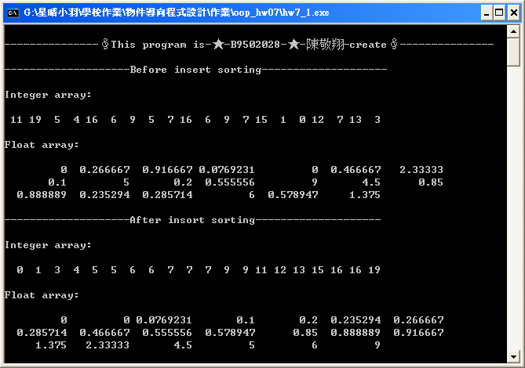

（2）Execute two：

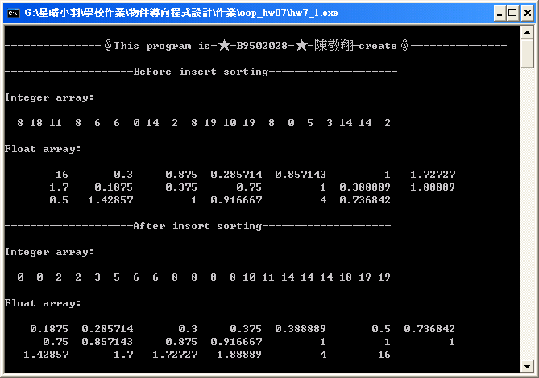
Problem Two
1、Exception handling：

（1）Try part：

try
{
throw(((intnumber>doublenumber)?intnumber:doublenumber));
cout << "They are equal!";
}

（2）Catch integer part：

catch(int bignumber)
{
cout << "\"Interger\" type big number is : " << bignumber;
}

（3）Catch double part：

catch(double bignumber)
{
cout << "\"Double\" type big number is : " << bignumber;
}

2、Total program and notes：

#include<iostream>

//Using directive.
using std::cin;
using std::cout;
using std::endl;

/****************************************/
/**************Main function*************/
/****************************************/
int main()
{
cout << endl << "---------------∮This program is-★-B9502028-★-陳敬翔-create∮---------------" << endl << endl;
//Declare an integer type variable "intnumber".
int intnumber;
//Declare a double type variable "doublenumber".
double doublenumber;
cout << "Please enter an integer type number : ";
cin >> intnumber;
cout << "Please enter a double type number : ";
cin >> doublenumber;
cout << endl;
//Try block contains code that might throw exception,
//and code that should not execute if an exception occurs.
try
{
throw(( (intnumber > doublenumber)? intnumber : doublenumber));
//If it do not generat a excution, print out "They are equal!".
cout << "They are equal!";
}
//Exception handler handles a "get integer type" exception.
catch(int bignumber)
{
cout << "\"Interger\" type big number is : " << bignumber;
}
//Exception handler handles a "get double type" exception.
catch(double bignumber)
{
cout << "\"Double\" type big number is : " << bignumber;
}
getchar();
return 0;
}

3、Running result：

（1）Compare 28 and 79.28：

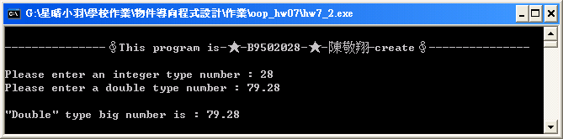

Of course, double type 79.28 greater than integer type 28.
（2）Compare 100 and 100.0：

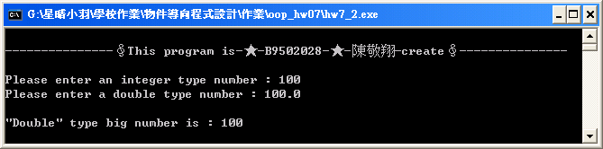

Integer type 100 should be equal to double type 100.0, but it still catch double type exception and let integer type transform double type.

（3）Compare 100 and 100：

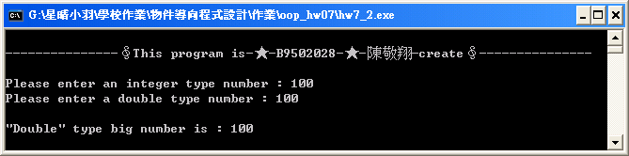

Observe easily in here.

（4）Compare 28 and 79：

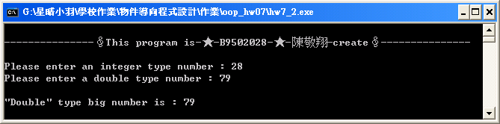

（4）Compare 79 and 28.79：

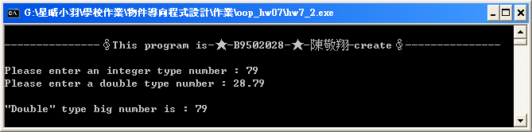

Bingo! only the double catch handler executes, regardless of whether the int or the double is returned.

